ENGI 9804 Lab 01

Chang Wan

202381126

Ziyang Zhou

202193950

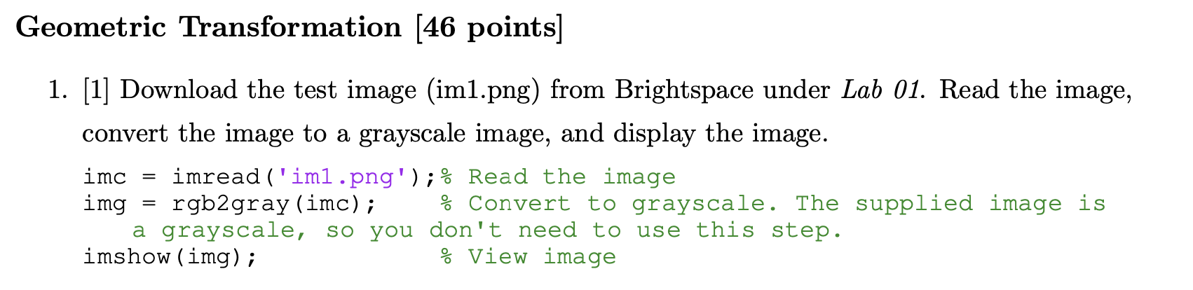

Answer:

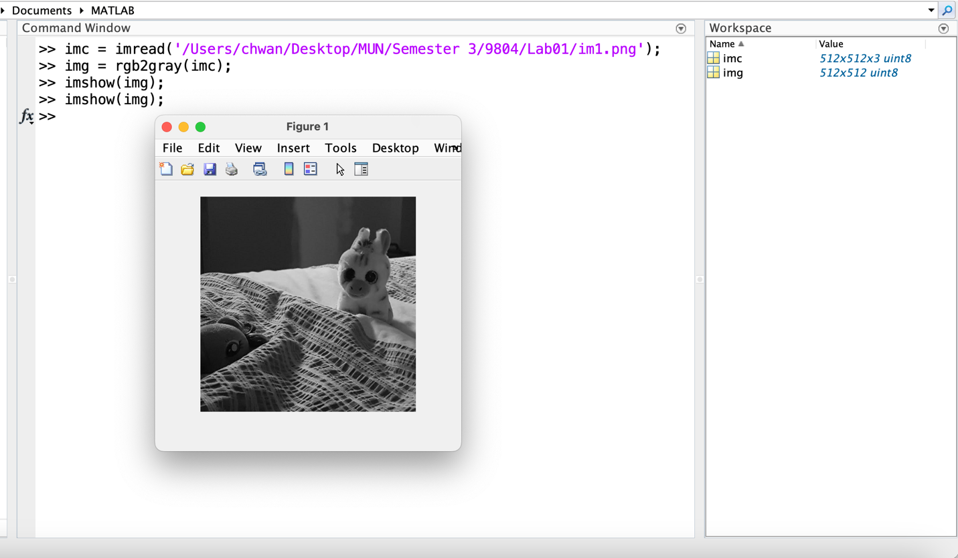

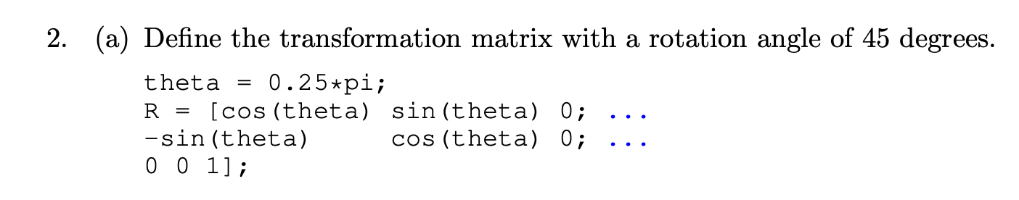

Answer:

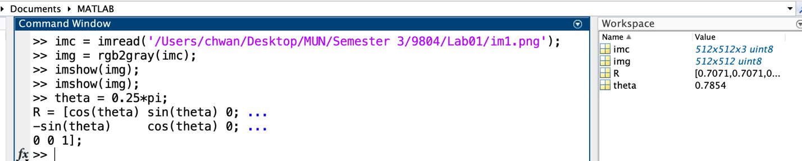

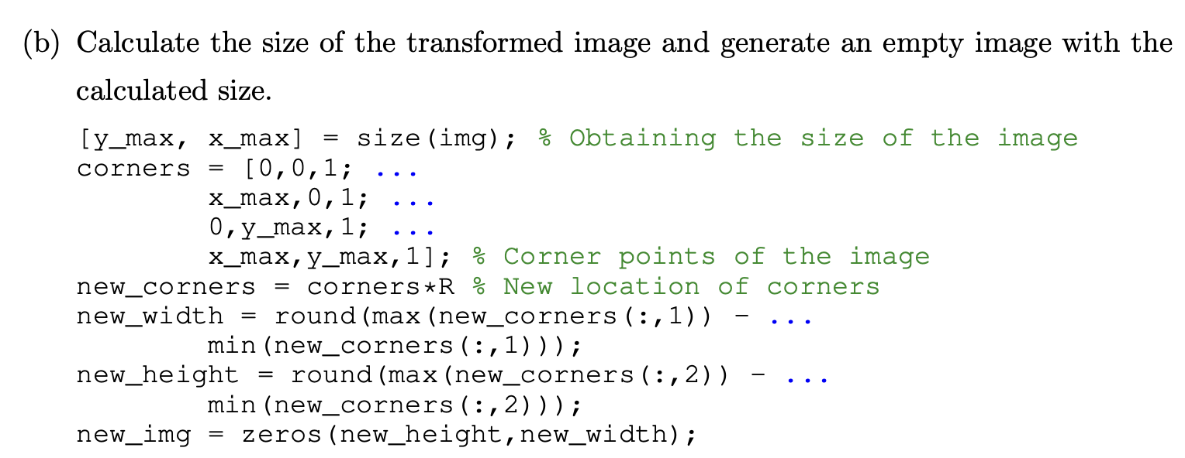

Answer:

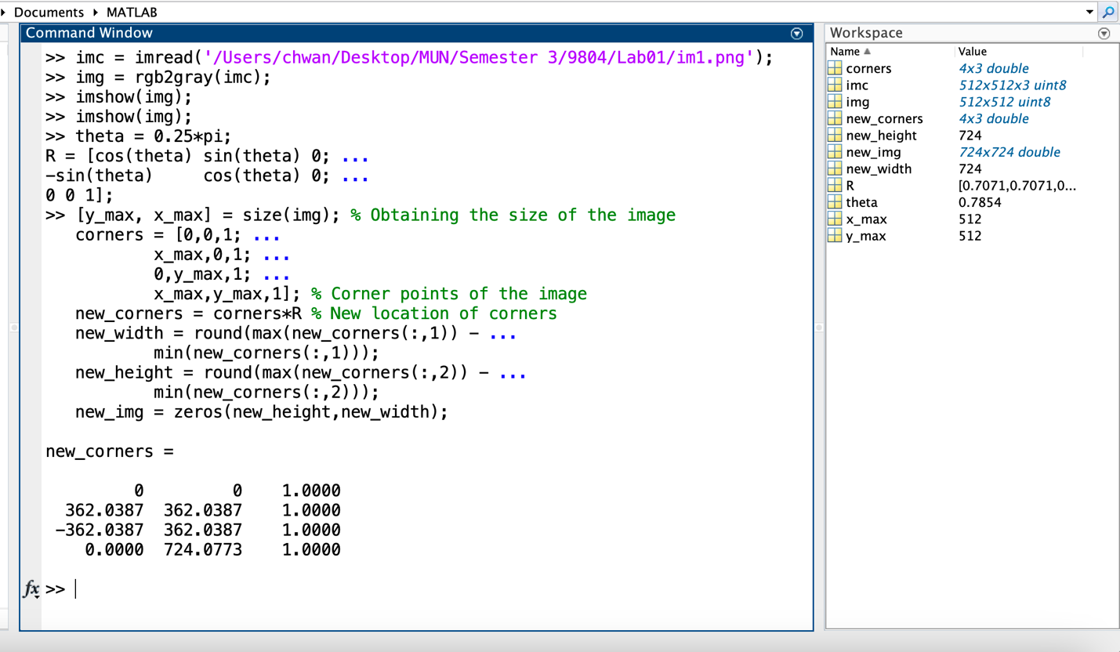

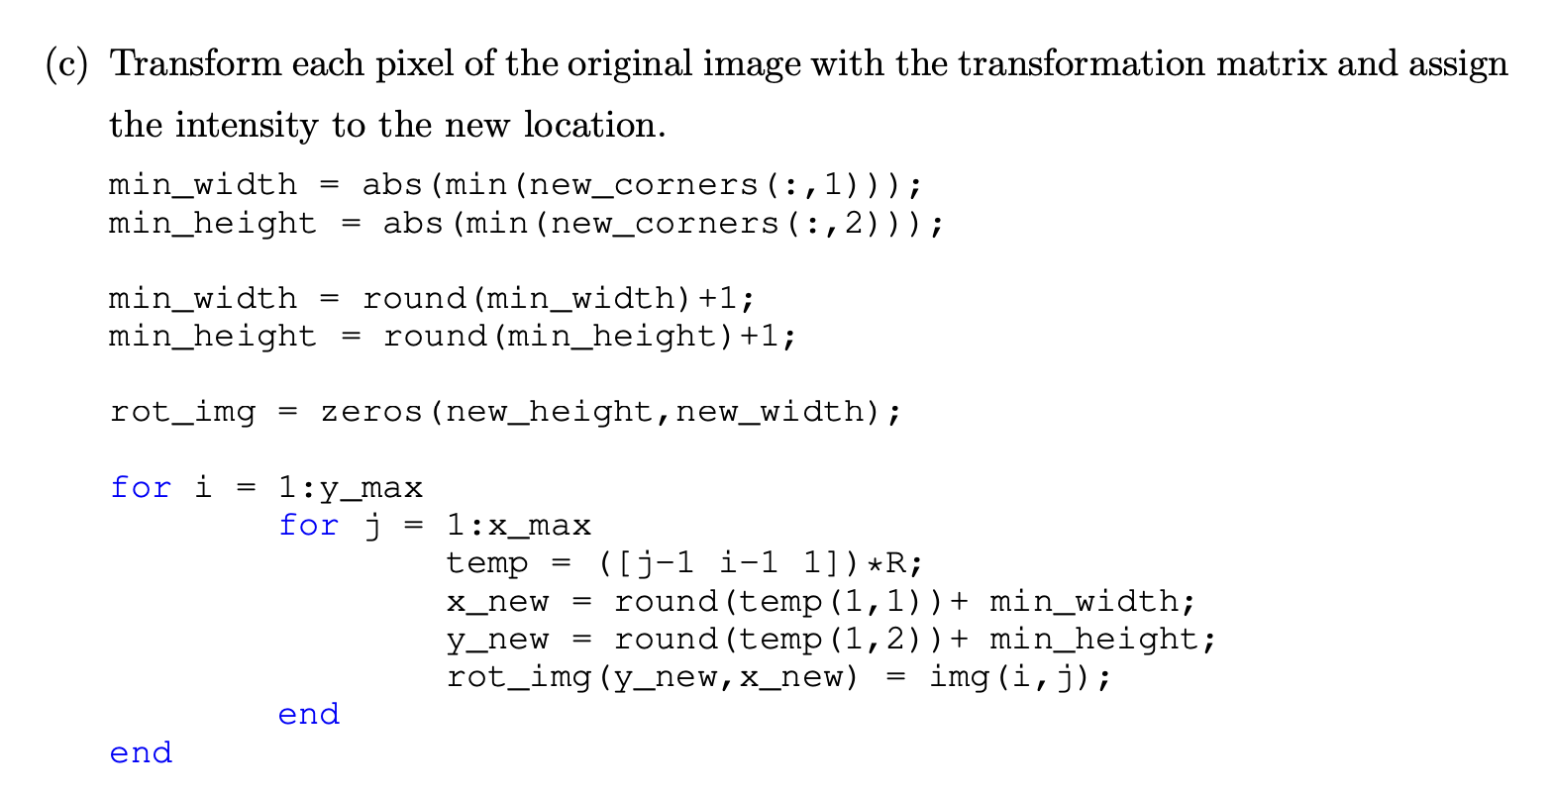

Answer:

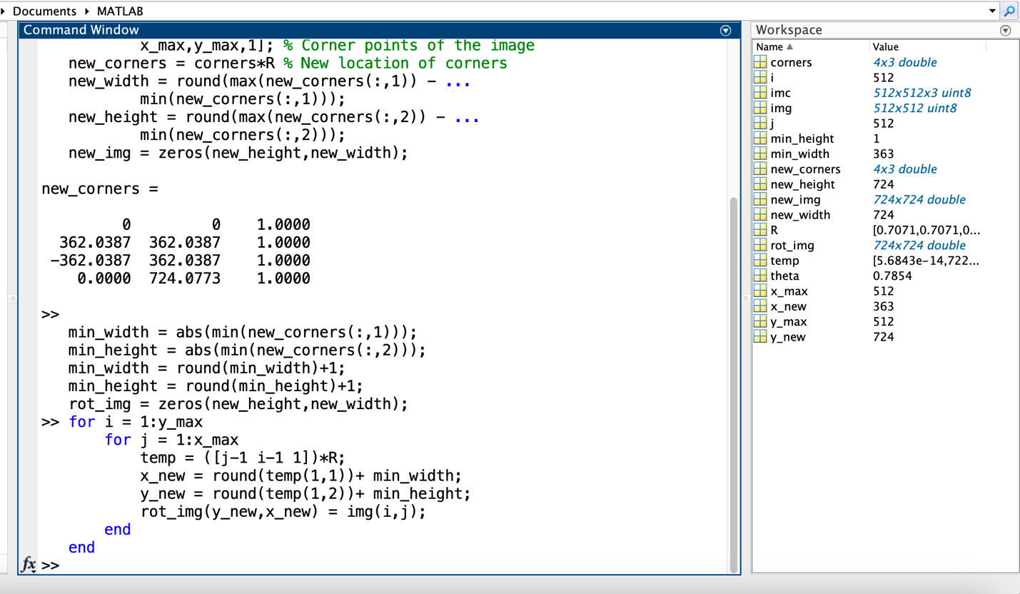

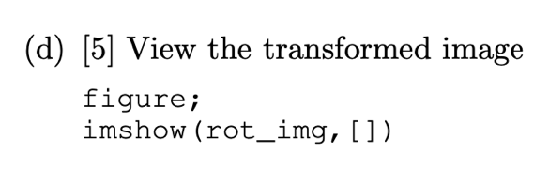

Answer:

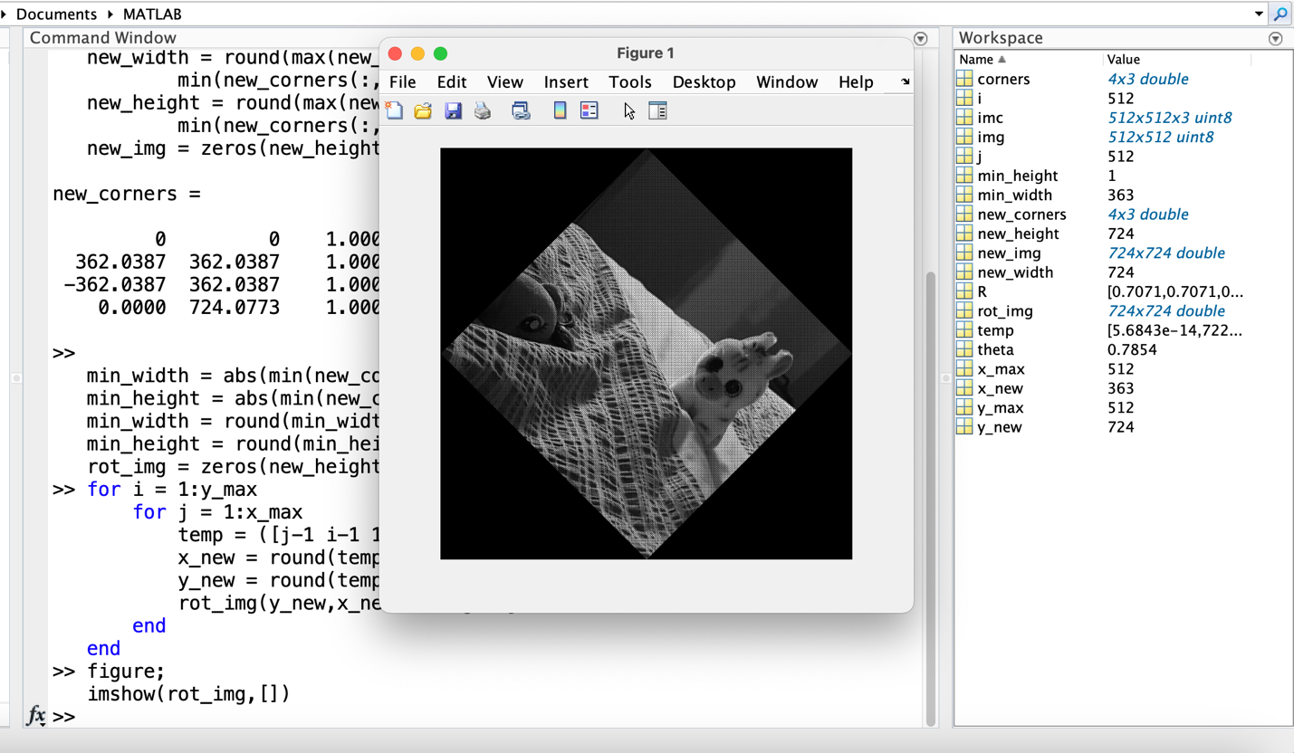



Answer:

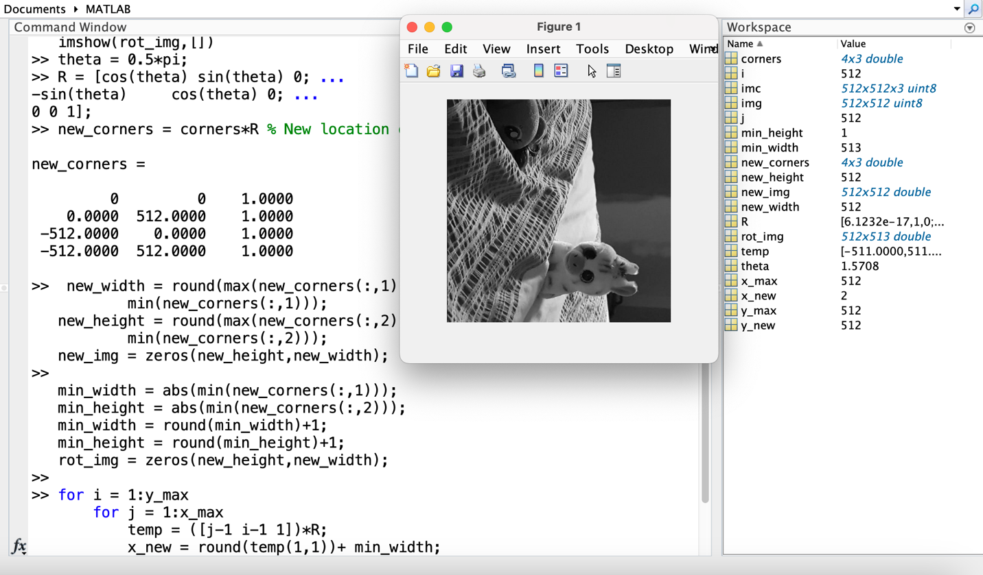



Answer:

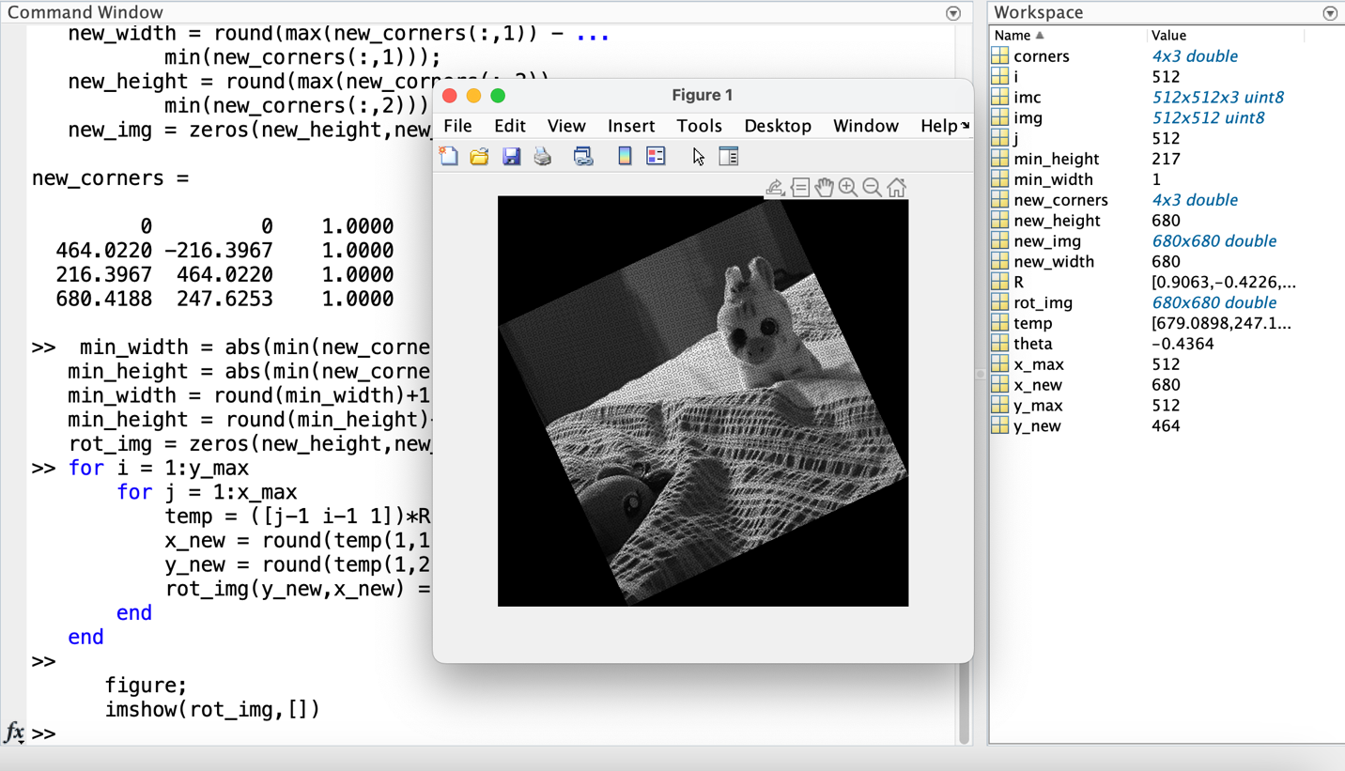



Answer:

*Because there is an empty image created as the size of original image. After the rotate of original image, when it cannot fill all the empty image, the empty image background will might show.*

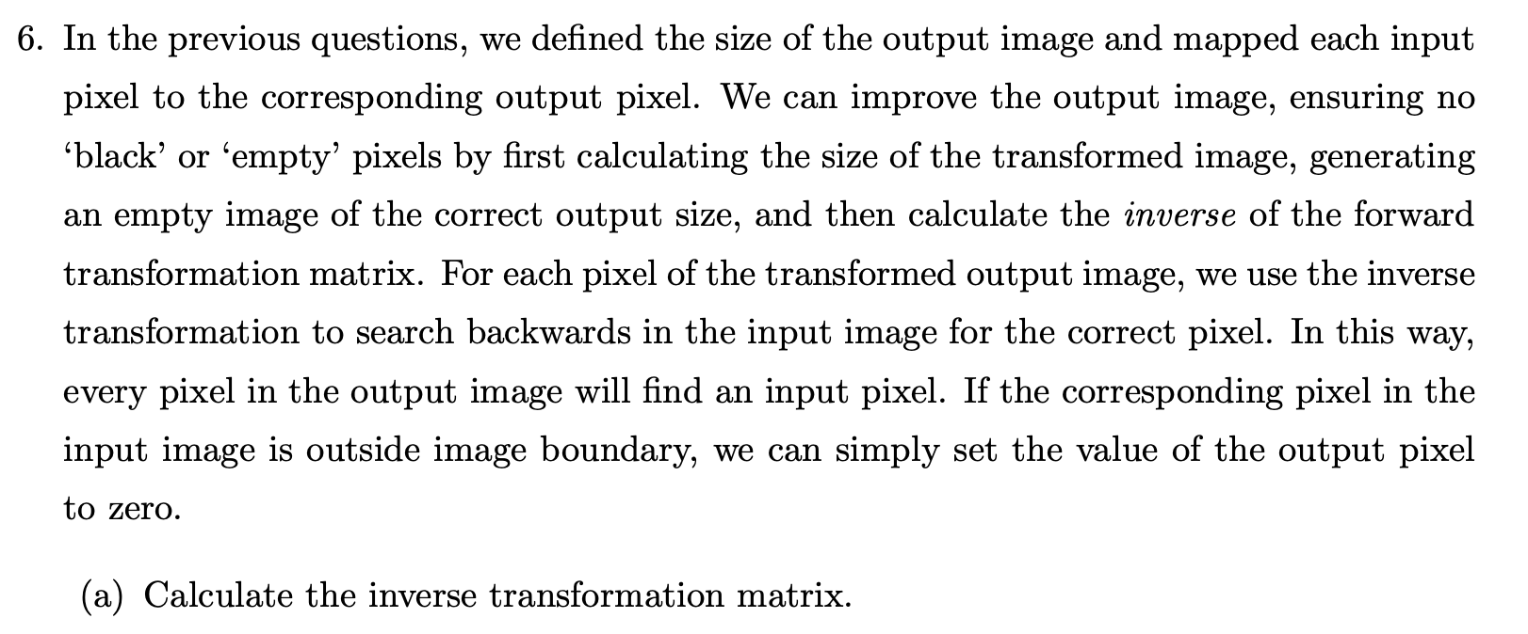

Answer:

For rotation:

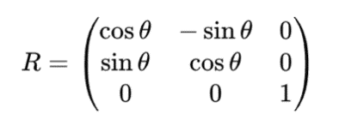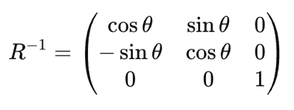

For Scaling:

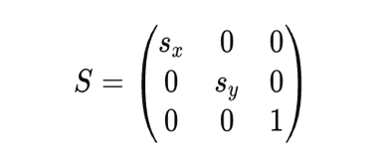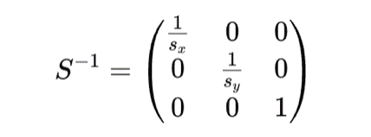

For Translation:

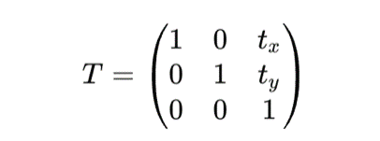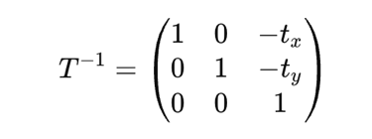

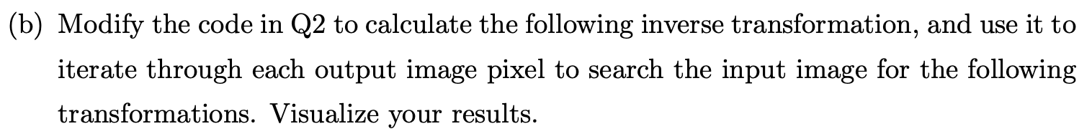

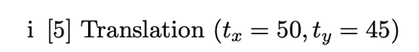

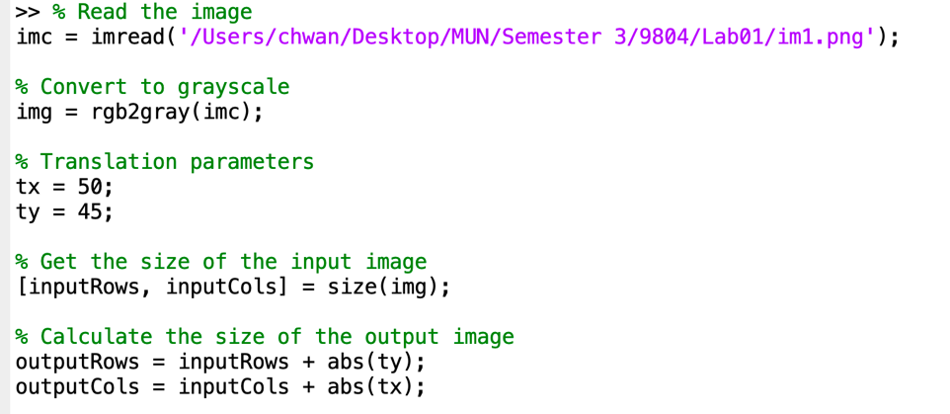

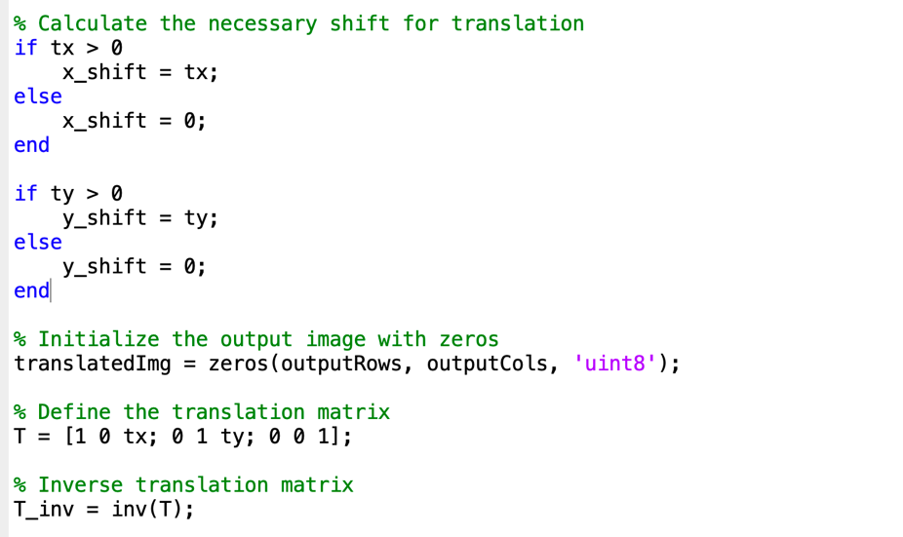

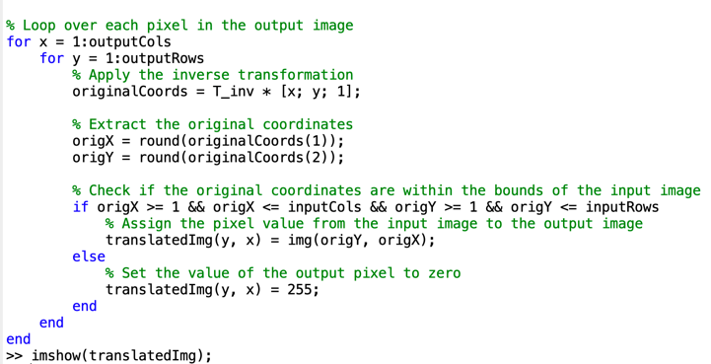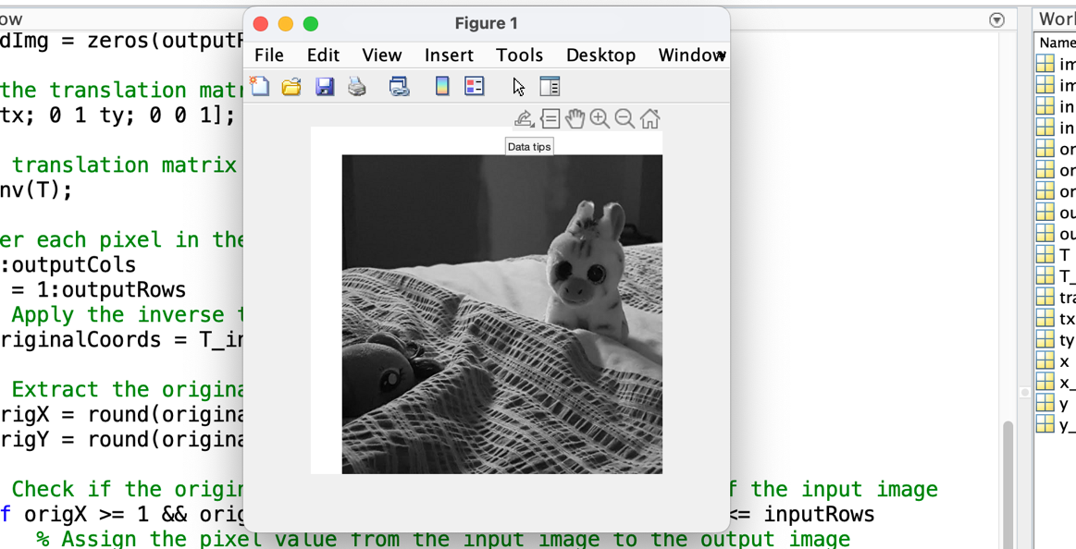

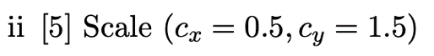

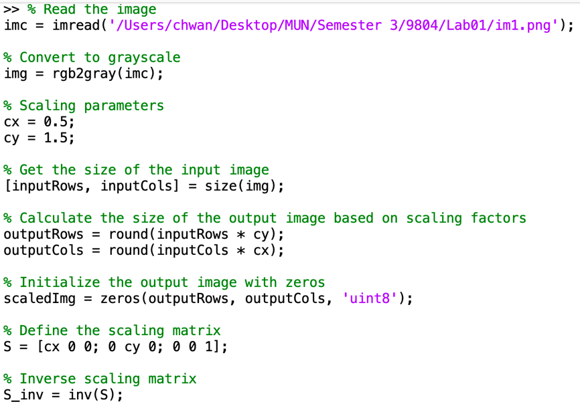

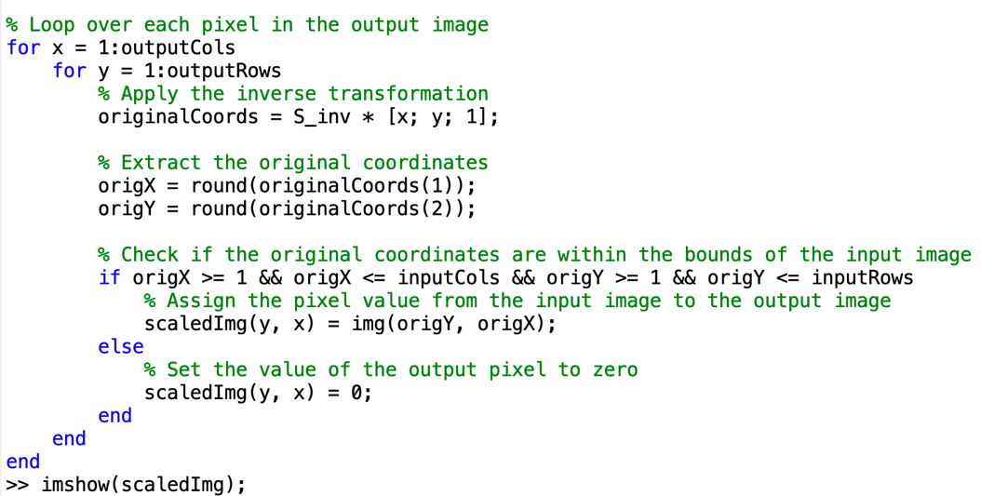

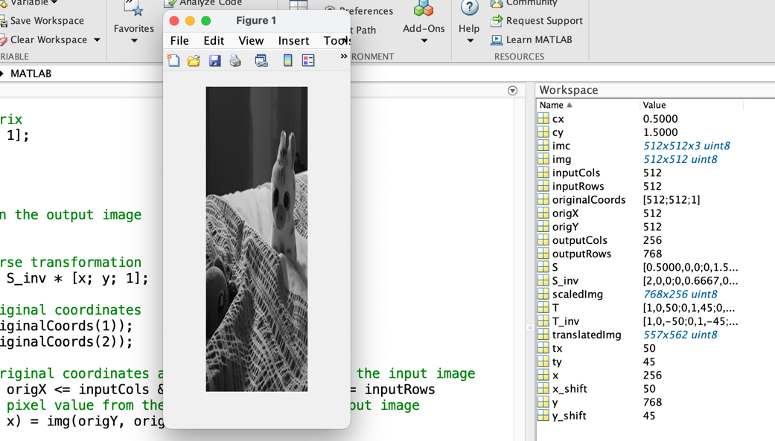

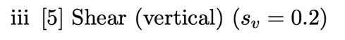

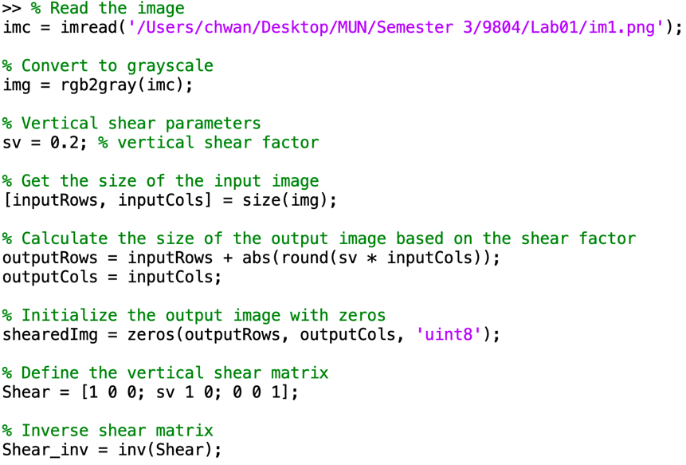

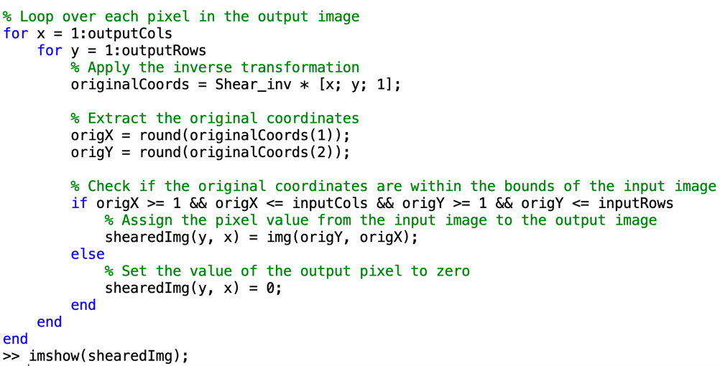

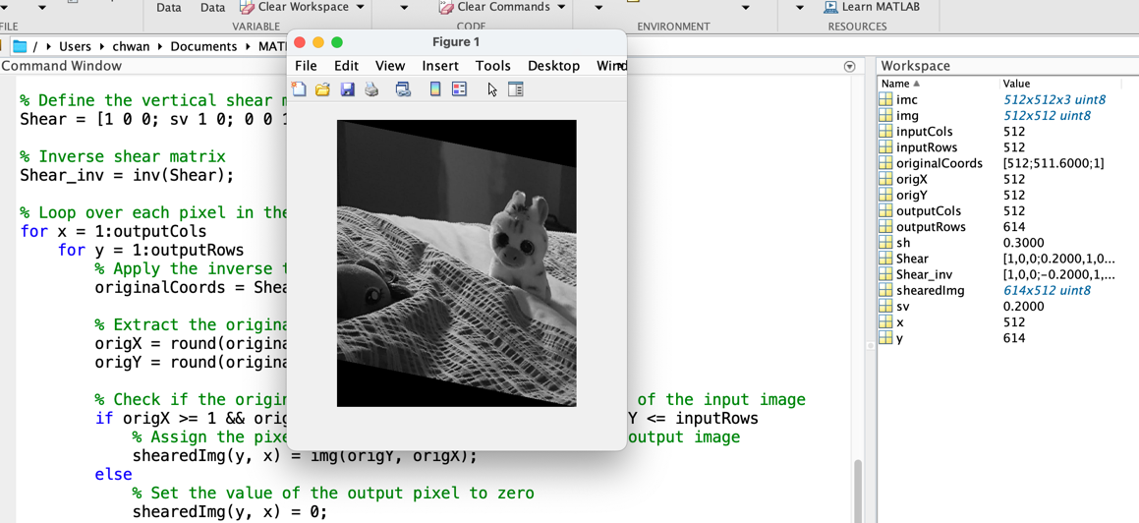

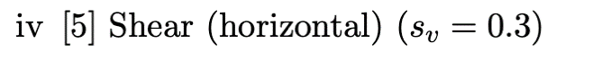

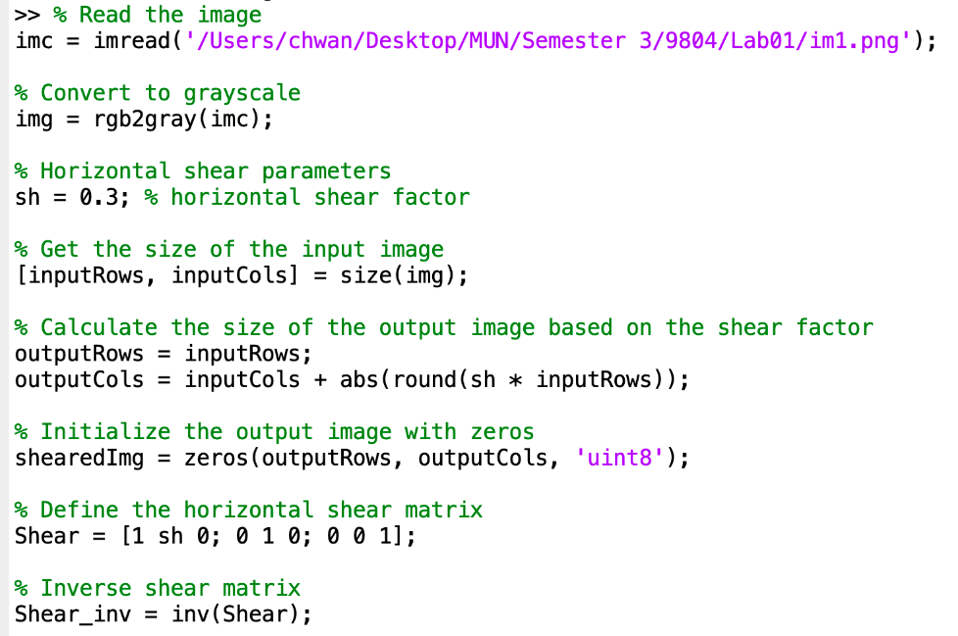

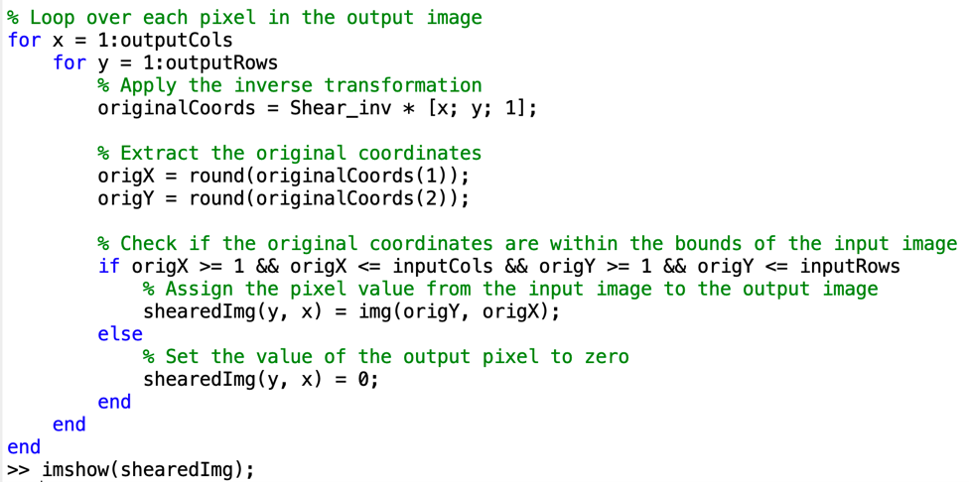

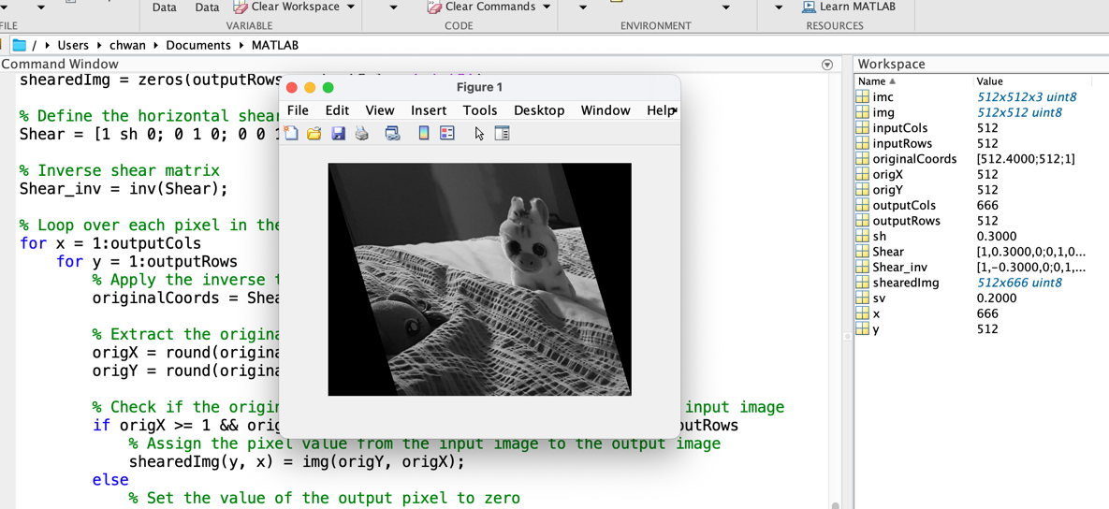



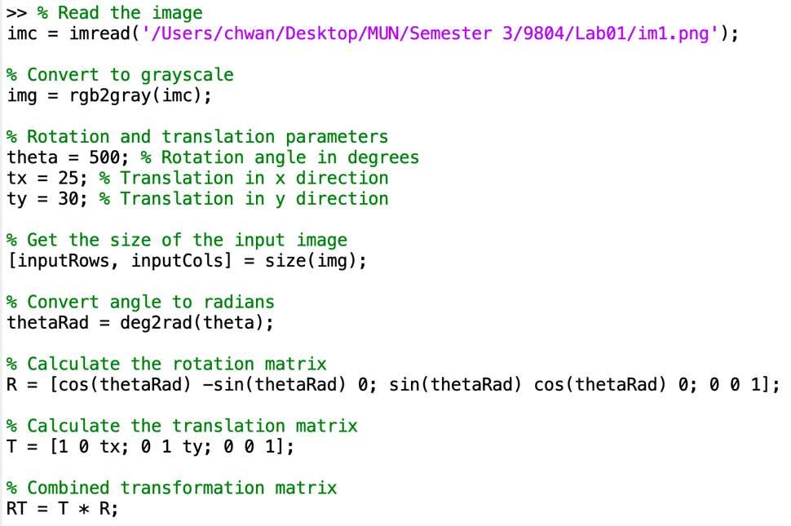

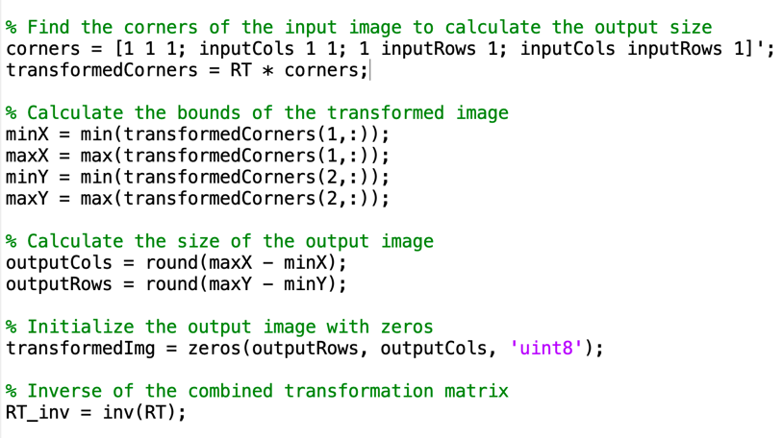

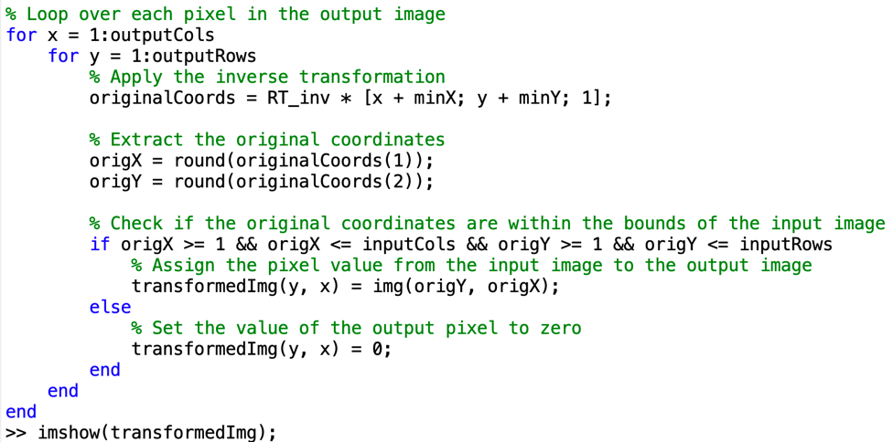

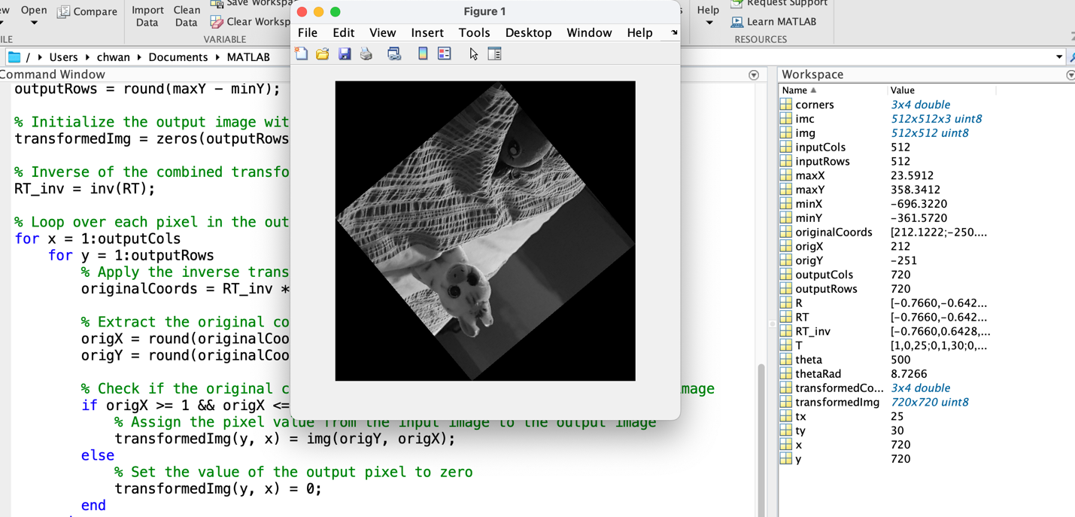

Performance evaluation:

*The built-in functions in MATLAB are highly optimized for performance, while custom implementations, especially those involving loops and manual calculations, tend to be slower.*

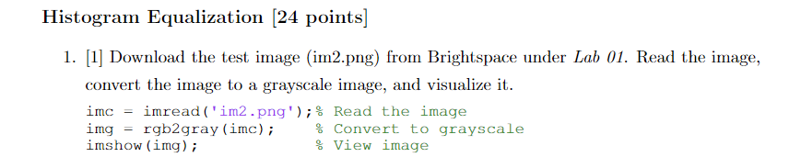

Answer：

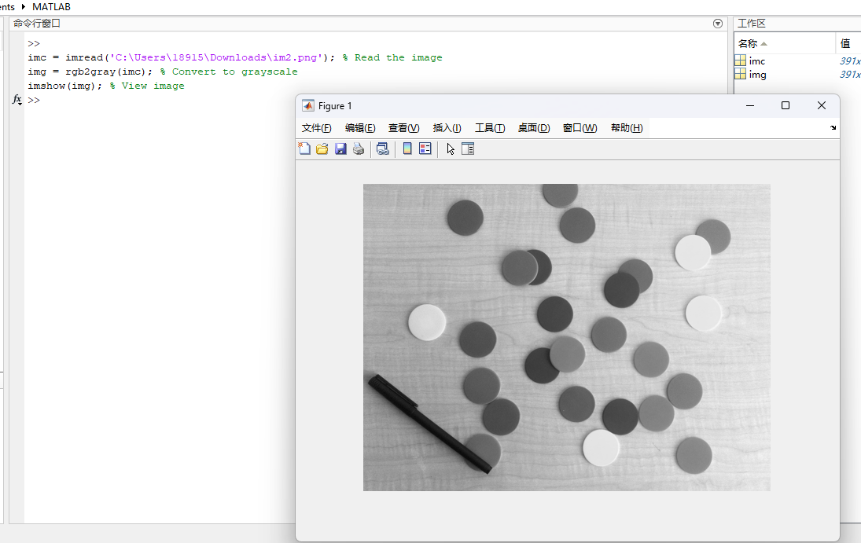

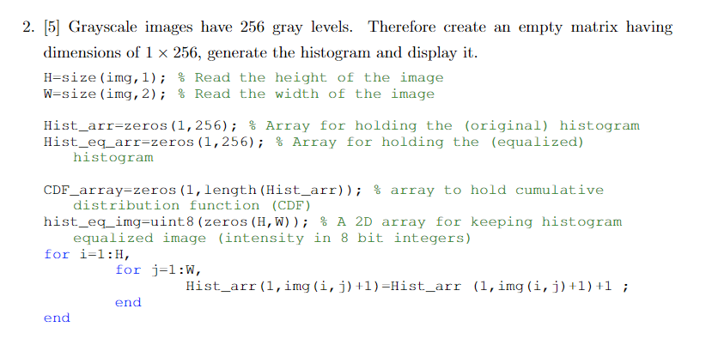

Answer:

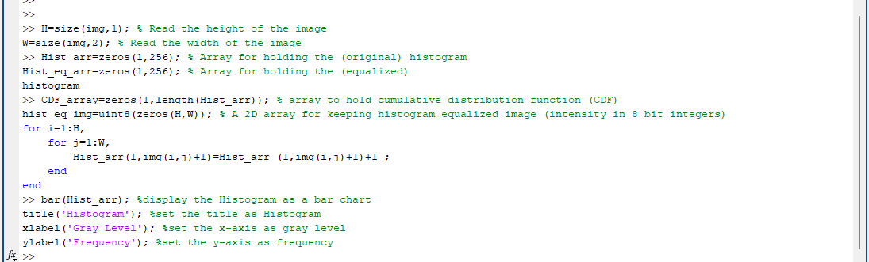

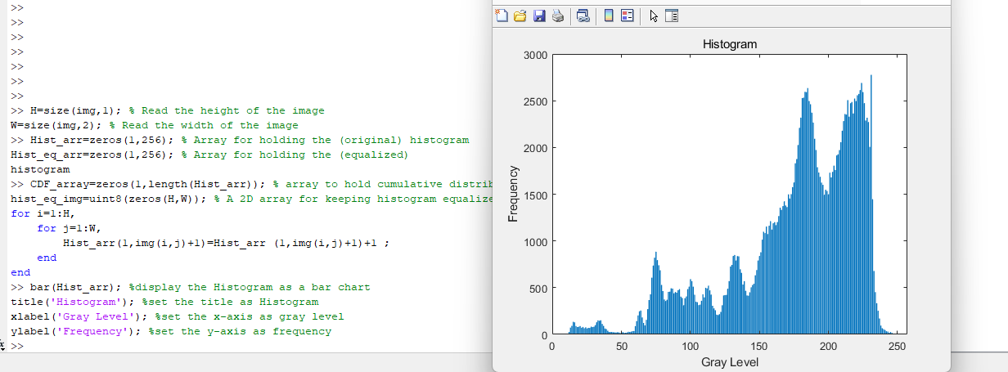

Explanation:

*The formal code part has been divided into 3 parts. The first part is reading the height and width of the image, save them as H and W. Then it initialized a 1*256 array with all elements initialized as 0. This array is used to store the number of pixels for each gray level.*

*Then using a double loop to iterate each pixel in the image. img(i, j) + 1 calculate the gray level of the current iterated pixel. Once the gray level of this pixel is calculated, the count of pixels for this gray level in the array we intialized before,which is Hist_arr , will be added 1 count. After iterating all the pixels in the image, the Hist_arr will store a 1*256 array, each element represents the number of pixels for each gray level.*

*Then we use a bar chart to display the Histogram, name it as Histogram and set the x-axis as gray level and y-axis as Frequency.*

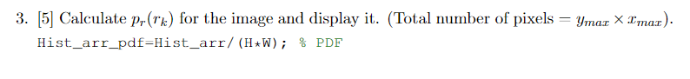

Answer:

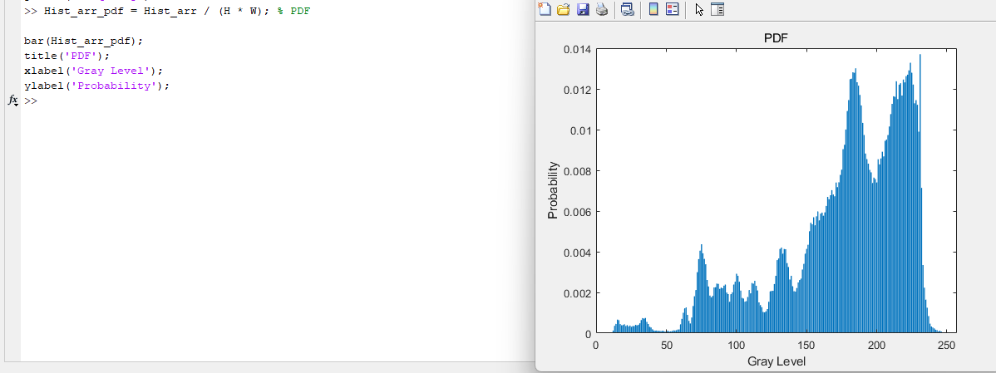

Explanation:

*Based on the PDF’s formula, we know that:*

*pr​(rk​)=nk​/(M×N)*

*Since we already have Hist_arr that stores all the number of pixels for each gray level, we need to divide them by the number of all the pixels, which is equal to H*W.*

*Then we display the PDF in a bar chart.*

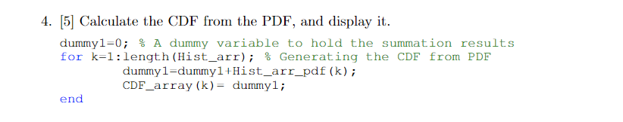

Answer:

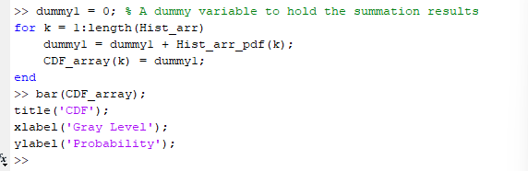

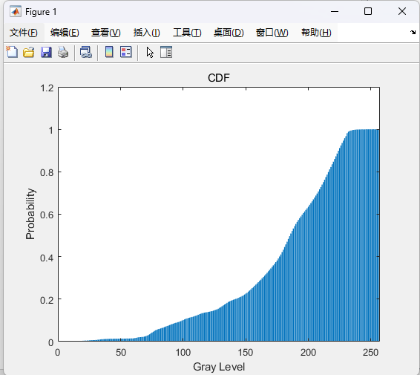

Explanation:

*Since we know that CDF is the for gray level rk is equal to the sum of all the PDF for the gray level that is below rk*

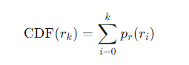

*\*This screenshot is from Chatgpt.*

*To get the CDF for Hist_arr, we use a dummy variable (initialized as 0) as the count for the sum of the PDF, then use a for loop to iterate the Hist_arr, the first gray level’s CDF is equal to the value of its PDF, then the next gray level’s CDF will be the sum of the previous sum of the PDF plus the current gray level’s PDF. We go through all the elements in the Hist_arr and get all the CDF for each gray level. Then we display it in a bar chart.*

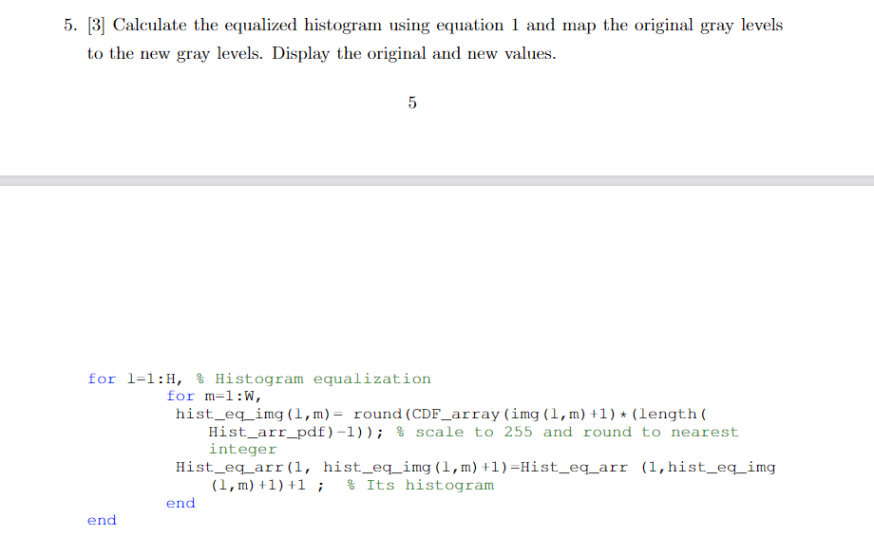

Answer:

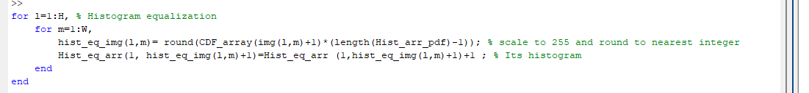



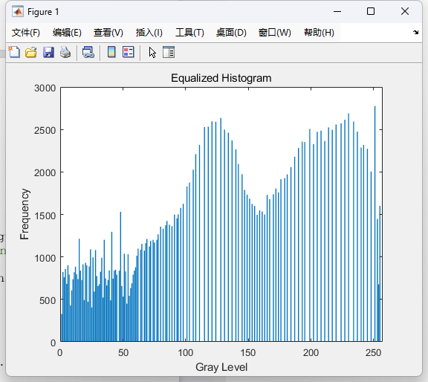

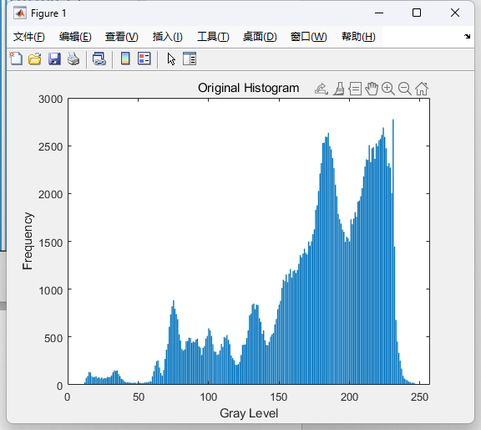

Explanation:

*Based on the Histogram equalization equation discussed in our lecture, we have the formula:  
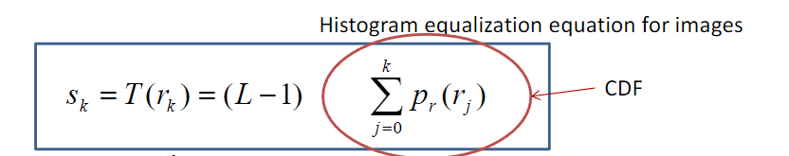*

*\*This screenshot is from the lecture note.*

*We use a double loop to iterate each pixel in the image. For each pixel:*

*L in our problem is equal to the length of the Hist_arr_pdf, which represents the total number of the gray level.*

*Then we use (L-1) to multiply this pixel’s CDF, then round it to the nearest integer to get T(rk). Then we save it into the new histogram equalized image hist_eq_img.  
Then in the new equalized histogram, we will update the count of each gray level.*



Answer:



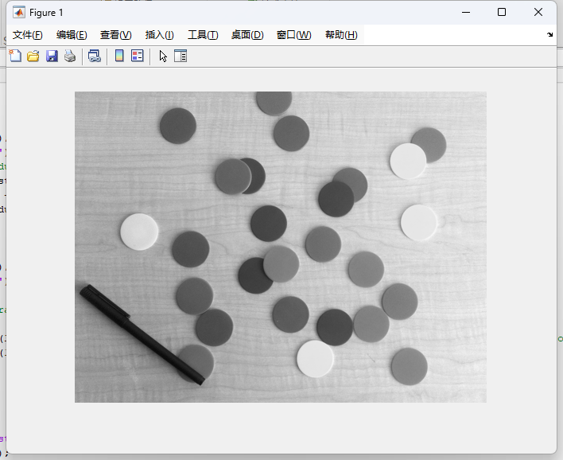



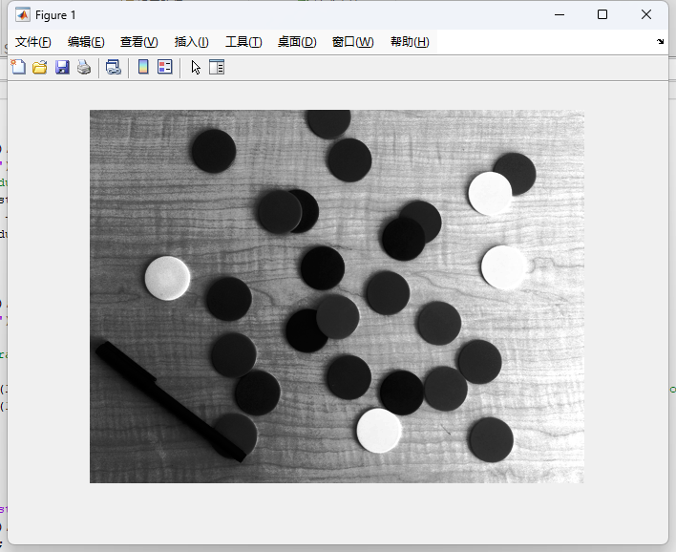

*Performance Evaluation*

*The result of our histogram equalization process cannot be called perfect. Though after the equalization, the contrast of the gray level in this image is improved, we still have a lot of circle objects in the original image. Even after the equalization, the gray level range of this circle objects will still show more frequently than the gray level ranges of the background.*